Collection Framework in Java
Java Collection Framework (JCF) is a set of classes and interfaces that provide ready-made data structures to store and manipulate groups of objects efficiently.
- Java provides built-in collection classes like List, Set, Map and Queue, so developers don’t need to write their own data management algorithms.
- The Collection Framework improves productivity by making code more reusable, maintainable and faster to develop.

Features of Java Collection Framework
- Provides ready-to-use data structures (e.g., ArrayList, HashSet, HashMap).9
- Offers interfaces (Collection, List, Set, Map, Queue) to define standard behaviors.
- Supports dynamic resizing, unlike arrays with a fixed size.
- Includes algorithms (sorting, searching, iteration) via the Collections utility class.
- Improves code reusability and performance by reducing boilerplate code.

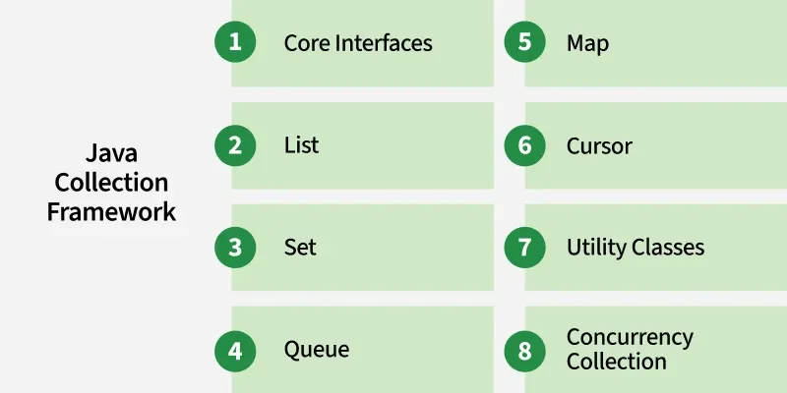

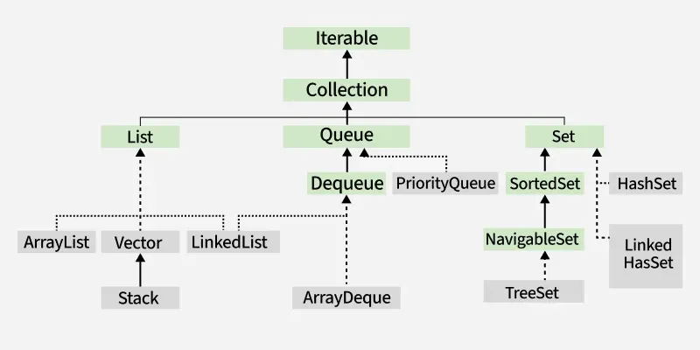

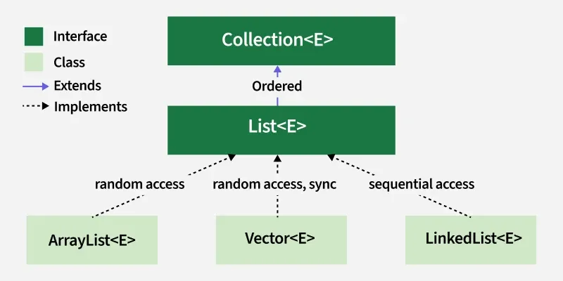

List Implementations
Lists represent ordered collections that allow duplicate elements and positional access. They include dynamic arrays, linked structures and legacy classes designed for sequential storage.
- ArrayList
- LinkedList
- Vector
- Stack
- AbstractList
- AbstractSequentialList

- ArrayList: It implement using resizable array, offers fast random access but slower insert/delete.
- LinkedList: It implement using Doubly-linked list, efficient for frequent insertions and deletions.
- Vector: It implement using Legacy synchronized dynamic array, thread-safe but slower.
- Stack: It implement using a LIFO (Last-In-First-Out) subclass of Vector for stack operations.

ArrayList vs LinkedList
ArrayList | LinkedList
Underlying structure is Dynamic Array | Underlying structure is Doubly-linked list
O(1) - Fast random access | O(n) - Slow random access
Memory is lower (contiguous memory) | Memory is higher (extra pointers per node)
Iteration speed is faster | Iteration speed is slower.
Insertion and deletion is slower | Insertion and deletion is faster.

2. Set
- Set represents an unordered collection with no duplicate elements.
- Implementing Classes: HashSet, TreeSet, LinkedHashSet, EnumSet, CopyOnWriteArraySet.
- Declaration:
public interface Set<E> extends Collection<E>
- The set interface does not allow duplicate elements.
- It can contain at most one null value except TreeSet implementation which does not allow null.
- The set interface provides efficient search, insertion, and deletion operations.

3. SortedSet
- SortedSet extends Set and maintains elements in a sorted order.
- Provides methods to handle range-based operations.
- Implementing Class: TreeSet.
- Declaration:
public interface SortedSet<E> extends Set<E>

4. NavigableSet
- NavigableSet extends SortedSet and provides navigation methods like lower(), floor(), ceiling(), and higher().
- Implementing Class: TreeSet.
- Declaration:
public interface NavigableSet<E> extends SortedSet<E>
Classes that implement the Set interface
- HashSet: A set that stores unique elements without any specific order, using a hash table and allows one null element.
- EnumSet : A high-performance set designed specifically for enum types, where all elements must belong to the same enum.
- LinkedHashSet: A set that maintains the order of insertion while storing unique elements.
- TreeSet: A set that stores unique elements in sorted order, either by natural ordering or a specified comparator.

5. Queue
- Queue represents a collection following FIFO (First-In-First-Out) order.
- Implementing Classes: PriorityQueue, Deque, ArrayDeque, LinkedList
- Declaration:
public interface Queue<E> extends Collection<E>

5. Deque
- Deque extends Queue and allows elements to be added/removed from both ends.
- Implementing Classes: ArrayDeque, LinkedList.
- Declaration:
public interface Deque<E> extends Queue<E>

List vs Set
Both the List interface and the Set interface inherits the Collection interface. However, there exists some differences between them.

List | Set
The List is an ordered sequence. | The Set is an unordered sequence.
List allows duplicate elements | Set doesn’t allow duplicate elements.
Elements by their position can be accessed. | Position access to elements is not allowed.
Multiple null elements can be stored. | The null element can store only once.
List implementations are ArrayList, LinkedList, Vector, Stack | Set implementations are HashSet, LinkedHashSet.

Map Interface in Java
In Java, the Map Interface is part of the java.util package and represents a collection of key-value pairs, where Keys should be unique, but values can be duplicated.
- It provides efficient retrieval, insertion, and deletion operations based on keys.
- Keys should be unique, but values can be duplicated.
- HashMap and LinkedHashMap allow one null key, and TreeMap does NOT allow null keys (if natural ordering is used).
- Use ConcurrentHashMap for thread-safe operations, or Collections.synchronizedMap() to make an existing map synchronized.

Map Interface in Java
In Java, the Map Interface is part of the java.util package and represents a collection of key-value pairs, where Keys should be unique, but values can be duplicated.
- It provides efficient retrieval, insertion, and deletion operations based on keys.
- Keys should be unique, but values can be duplicated.
- HashMap and LinkedHashMap allow one null key, and TreeMap does NOT allow null keys (if natural ordering is used).
- Use ConcurrentHashMap for thread-safe operations, or Collections.synchronizedMap() to make an existing map synchronized.
Declaration of the Map interface
public interface Map<K, V>
- K -> Type of keys maintained by the map
- V -> Type of mapped values

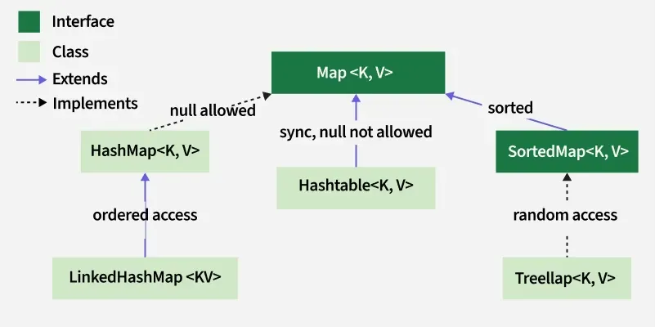

Implemented Classes of Map Interafe
- HashMap: Stores key-value pairs using hashing for fast access, insertion, and deletion.
- LinkedHashMap: Similar to HashMap but maintains the insertion order of keys.
- TreeMap: Stores key-value pairs in sorted order using natural ordering or a custom comparator.
- Hashtable: A synchronized Map implementation that doesn’t allow null keys or values.

LinkedHashMap in Java

LinkedHashMap in Java implements the Map interface of the Collections Framework. It stores key-value pairs while maintaining the insertion order of the entries. It maintains the order in which elements are added.
- Stores unique key-value pairs.
- Maintains insertion order.
- Allows one null key and multiple null values.
- It is not thread-safe; to synchronize it, use Collections.synchronizedMap().

It stores data as nodes similar to a doubly-linked list, maintaining insertion order. Each node contains:+

TreeMap
A TreeMap in Java is a part of the java.util package that implements the Map interface. It stores key-value pairs in a sorted order using either a natural or custom comparator.
- TreeMap does not allow null keys, but allows null values.

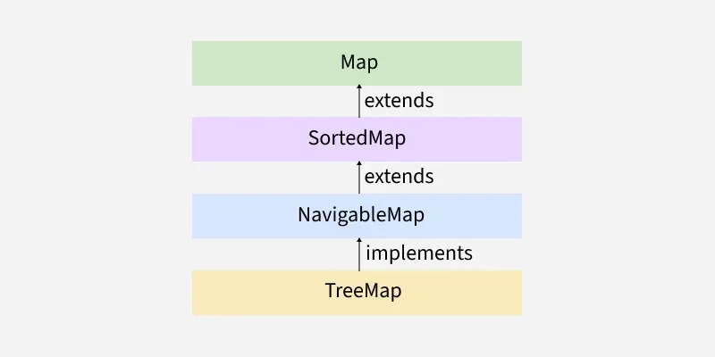

LinkedHashMap
LinkedHashMap in Java is an implementation of the Map interface that combines the features of a hash table and a doubly-linked list. It extends HashMap and, unlike HashMap, guarantees a predictable iteration order.

- Maintains Insertion Order:
By default, LinkedHashMap preserves the order in which key-value pairs are inserted into the map. When iterating over a LinkedHashMap, elements will be returned in the order they were added.
- Performance:
While LinkedHashMap provides ordered iteration, its performance for basic operations like put, get, and remove is generally similar to HashMap, offering average constant-time complexity. However, it uses slightly more memory than HashMap due to the overhead of maintaining the doubly-linked list.
- Not Thread-Safe:
Like HashMap, LinkedHashMap is not synchronized. If used in a multi-threaded environment, external synchronization or wrapping it with Collections.synchronizedMap() is necessary to prevent data inconsistency.

WeakHashMap
WeakHashMap in Java is an implementation of the Map interface where the keys are stored as weak references. This distinguishes it from a regular HashMap where keys are held by strong references.
Key Characteristics and Behavior:
- Weak References for Keys:
The defining feature of WeakHashMap is that its keys are wrapped in WeakReference objects. This means that if an object used as a key in a WeakHashMap is no longer strongly referenced by any other part of the program, it becomes eligible for garbage collection.
- Automatic Entry Removal:
When a key object in a WeakHashMap is garbage collected, the corresponding entry (key-value pair) is automatically removed from the map. This helps prevent memory leaks in scenarios where you might otherwise hold onto objects longer than necessary.
- Garbage Collection Dependent:
The removal of entries from a WeakHashMap is non-deterministic and depends on the Java Virtual Machine's (JVM) garbage collection process. You cannot precisely control when an entry will be removed.
How it Works (Simplified):

EnumMap Class in Java
EnumMap is a specialized implementation of the Map interface for enumeration types. It extends AbstractMap and implements the Map interface in Java. It belongs to java.util package. A few important features of EnumMap are as follows:
- The EnumMap class is a member of the Java Collections Framework and is not synchronized.
- EnumMap is an ordered collection and they are maintained in the natural order of their keys (the natural order of keys means the order in which enum constants are declared inside the enum type).
- It’s a high-performance map implementation, much faster than HashMap.
- All keys of each EnumMap instance must be keys of a single enum type.
- EnumMap doesn't allow a null key and throws NullPointerException when we attempt to insert the null key.
- Iterators returned by the collection views are weakly consistent: they will never throw ConcurrentModificationException and they may or may not show the effects of any modifications to the map that occur while the iteration is in progress.
- EnumMap is internally represented as arrays. This representation is extremely compact and efficient.

ZZZ

